**PROJECT REPORT**

**Create a Secure Chat Application with End-to-End Encryption**

Submitted by: Submitted to:

**KRISHAN KUMAR SHARMA (23CSA2BC017) Mr. Narayan vyas**

**CHITRANSH DHARWAL (23CSA2BC162)**

**PAYAL (23CSA2BC074)**

**NOYA (23CSA2BC066)**

**KHUSH VIJAY (23CSA2BC137)**

**Table of Contents**

**1. Introduction**

1.1. Overview of Secure Communication

1.2. Importance of End-to-End Encryption (E2EE)

1.3. Scope of the Report

**2. System Design and Architecture**

2.1. Key Technologies Used

2.2. System Architecture

2.3. Database Structure and Message Storage

**3. Implementation of End-to-End Encryption**

3.2. Symmetric Encryption (AES) for Messages

3.3. Public Key Encryption (RSA) for Key Exchange

3.4. Secure Authentication and Password Management (SHA-256)

**4. Secure Communication Protocols**

4.1. WebSockets for Real-Time Messaging

4.2. Secure Data Transmission with HTTPS

**5. Security Considerations and Risk Management**

5.1. Potential Threats and Countermeasures

5.2. Secure Key Management Strategies

**6. Testing and Performance Optimization**

6.1. Unit Testing for Encryption/Decryption

6.2. Penetration Testing and Vulnerability Scanning

6.3. Performance Optimization

**7. Deployment and Hosting Considerations**

7.1. Cloud vs. On-Premises Deployment

7.2. Dockerization for Secure Containerized Deployment

**8. Future Enhancements**

8.1. Implementing Secure Group Chats

8.2. Secure File Sharing with End-to-End Encryption

8.3. Multi-Factor Authentication (MFA) Support

**9. Conclusion**

9.1. Summary of Achievements

9.2. Challenges Faced

9.3. Future Enhancements

9.4. Real-World Impact

9.5. Final Thoughts

**10. References**

**1.Introduction**

**1.1. Overview of Secure Communication**

Due to the fast pace of digital communications, there has been a heightened concern for privacy. Centralized servers in traditional messaging systems make messages vulnerable to interception, alteration, and even leakage. End-to-End Encryption makes sure data being shared between users stays private and out of reach for unauthorized individuals.

**1.2. Importance of End-to-End Encryption (E2EE)**

End-to-End Encryption (E2EE) is an encryption technique by which messages are encrypted on one's own device and can only be decrypted on the recipient's device. What this implies is that even when a third party, like a hacker, internet service provider (ISP), or server administrator intercepts the message, they do not have any way of deciphering its content.  
  
Without encryption, data are susceptible to:  
  
Man-in-the-Middle (MITM) Attacks – Data interception when in transit.  
  
Data Breaches – Illegal access to centralized databases.  
  
Unauthorized Modifications – Intruders modifying messages prior to receiving them by the recipient.

**1.3. Scope of the Report**

The Secure Chat Application seeks to offer an entirely encrypted communication interface whereby messages are transmitted safely between users. The project uses Advanced Encryption Standard (AES) for encrypting messages, RSA for key exchange, and SHA for password hashing for enhanced security. It also uses Django Channels and WebSockets for real-time messaging.

**2. System Design and Architecture**

**2.1. Key Technologies Used**

The secure chat app combines several contemporary web technologies and security standards to provide real-time communication with end-to-end encryption. Below is a detailed explanation:  
Frontend:  
HTML, CSS, JavaScript – Offers the user interface to send and receive messages.  
WebSockets – Provides real-time bidirectional communication without the need for excessive HTTP requests.  
  
Backend:  
Django (Python Framework) – Manages authentication, user, and message routing.  
Django Channels – Supports asynchronous, real-time communication through WebSockets.  
  
Database:  
SQLite (Development) / PostgreSQL (Production) – Safely stores user credentials, encrypted messages, and key exchange data.

**2.2. System Architecture**

The chat application is based on a Zero Trust Model, in that no plaintext messages are ever stored on the server. The architecture has three key components:

1. Client-Side (User Devices)  
Users encrypt messages with AES encryption prior to sending.  
The AES key itself is encrypted with RSA to provide secure key exchange.  
Messages are sent over WebSockets over TLS to avoid unauthorized interception.

2. Server-Side (Django Web Server)  
The server never gets to see unencrypted messages and only forwards encrypted messages to the recipient.  
Django Channels and WebSockets take care of real-time communication, providing smooth message transmission.  
The server also facilitates user authentication and key exchange, allowing only authentic users to access the chat.

3. Receiver-Side  
The receiving end decrypts the AES key with his private RSA key.  
After the AES key is recovered, it decrypts the message from ciphertext back into plaintext.  
The decrypted message is rendered on the chat interface for the receiver.  
This Zero Trust strategy guarantees that even if the server is hacked, there is no leakage of plaintext messages.

**2.3. Database Structure and Message Storage**

• **Users Table:** Stores user credentials (hashed passwords).

• **Messages Table:** Stores encrypted messages along with timestamps.

• **Keys Table:** Stores encrypted AES keys for users.

**3. Implementation of End-to-End Encryption**

**3.2. Symmetric Encryption (AES) for Messages**

AES encrypts messages before they are sent and decrypts them upon receipt.

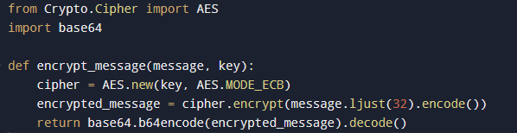

**3.3. Public Key Encryption (RSA) for Key Exchange**

Since AES requires a **shared key**, RSA is used to encrypt and securely exchange the AES key between users.

**RSA Key Exchange Example:**

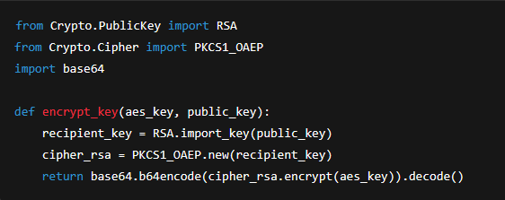

**3.4. Secure Authentication and Password Management (SHA-256)**

Django’s authentication system hashes passwords using SHA-256.

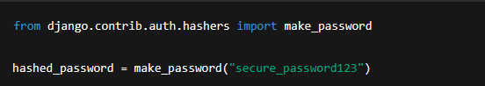

**4. Secure Communication Protocols**

**4.1. WebSockets for Real-Time Messaging**

WebSockets allow real-time communication between users, making the chat application responsive.

**WebSocket Consumer (consumers.py):**

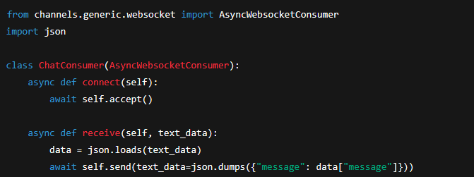

**4.2. Secure Data Transmission with HTTPS**

To protect communication from interception, **HTTPS with SSL/TLS encryption** is used.****

**5. Security Considerations and Risk Management**

**5.1. Potential Threats and Countermeasures**

|  |  |
| --- | --- |
| **Threat** | **Countermeasure** |
| MITM Attacks | E2EE ensures messages remain encrypted. |
| Brute Force Attacks | Strong AES and RSA keys prevent key guessing. |
| SQL Injections | Django ORM prevents SQL injection risks. |
| Replay Attacks | Unique message IDs and timestamps prevent replay. |

**5.2. Secure Key Management Strategies**

• RSA **private keys must be stored securely** on users' devices.

• AES keys should **expire after a certain duration** and be re-exchanged.

**6. Testing and Performance Optimization**

**6.1. Unit Testing for Encryption/Decryption**

Each encryption function is tested to ensure correct behavior.

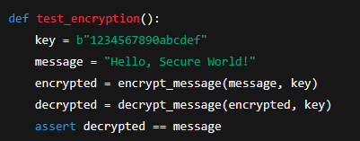

**6.2. Penetration Testing and Vulnerability Scanning**

• **Testing encryption robustness** using attack simulations.

• **Using OWASP ZAP** to detect vulnerabilities.

**6.3. Performance Optimization**

• **Reduced computational overhead** by caching encrypted session keys.

• **Optimized database queries** for quick user authentication.

**7. Deployment and Hosting Considerations**

**7.1. Cloud vs. On-Premises Deployment**

• **Cloud Deployment:** Scalable and easier maintenance.

• **On-Premises Deployment:** Provides full control over security.

**7.2. Dockerization for Secure Containerized Deployment**

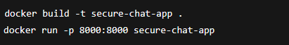

**8. Future Enhancements**

**8.1. Implementing Secure Group Chats**

Instead of **one-to-one encryption**, implement a group encryption mechanism using **session keys**.

**8.2. Secure File Sharing with End-to-End Encryption**

Encrypt files before sending them using **AES-GCM mode**. 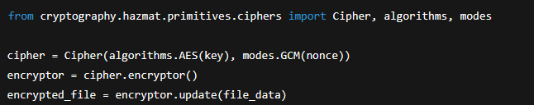

**8.3. Multi-Factor Authentication (MFA) Support**

Add an **OTP-based authentication** system to enhance security.

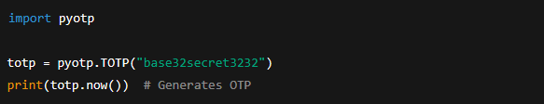

**9. Conclusion**

**9.1. Summary of Achievements**

This project successfully implemented a **secure chat application with end-to-end encryption**, ensuring user privacy and data security. By leveraging **AES for message encryption, RSA for key exchange, and SHA for password hashing**, the system maintains high security standards while allowing real-time communication. The **Django framework**, combined with **Django Channels and WebSockets**, provided a scalable and efficient real-time chat system. Additionally, the integration of **HTTPS, secure key storage, and database encryption** ensures protection against various cyber threats, including **man-in-the-middle attacks, brute-force attacks, and replay attacks**.

**9.2. Challenges Faced**

During the development of this application, several challenges were encountered:

* **Key Exchange Complexity:** Managing secure **key storage and distribution** without exposing private keys.
* **Performance Overhead:** AES encryption and decryption operations added **computational overhead**, which was optimized by using efficient key exchange mechanisms.
* **Ensuring Real-Time Communication:** **WebSockets were integrated with Django Channels** to provide an instant messaging experience without compromising security.
* **User Authentication and Session Management:** Implementing **secure password hashing (SHA-256) and multi-factor authentication (MFA)** to prevent unauthorized access.

**9.3. Future Enhancements**

While this chat application provides strong encryption and privacy, several improvements can be made in future iterations:

* **End-to-End Encrypted Group Chats:** Implementing **forward secrecy** to ensure that past messages remain secure even if encryption keys are compromised.
* **Encrypted File Sharing:** Adding **AES-GCM (Galois Counter Mode) encryption** for securely sharing images, documents, and other files.
* **Voice and Video Encryption:** Utilizing **Secure Real-time Transport Protocol (SRTP) with DTLS** to provide secure voice and video calls.
* **Decentralized Key Management:** Exploring **blockchain-based key exchange** to eliminate reliance on centralized servers.
* **AI-Powered Threat Detection:** Implementing **machine learning models** to detect suspicious behavior or potential security breaches.

**9.4. Real-World Impact**

The **increasing concerns over data privacy and digital surveillance** highlight the significance of secure communication applications. This project provides a **viable alternative to mainstream messaging platforms** by ensuring that **only the sender and receiver can access their conversations**. Implementing **Zero Trust security principles** makes it suitable for use in **corporate communications, government agencies, and personal messaging**, where data confidentiality is critical.

**9.5. Final Thoughts**

Developing this **Secure Chat Application with End-to-End Encryption** was an insightful experience, highlighting the **importance of cryptographic techniques, real-time communication, and secure system design**. While **current security measures are robust, evolving cyber threats demand continuous improvements** in encryption protocols and secure application development. By adopting **strong security best practices and continuously enhancing cryptographic implementations**, we can ensure that secure messaging solutions remain **reliable, private, and resistant to emerging threats**.

**10. References**

• **Rivest, R., Shamir, A., & Adleman, L.** (1978). A Method for Obtaining Digital Signatures and Public-Key Cryptosystems. *Communications of the ACM, 21*(2), 120-126.

• **Daemen, J., & Rijmen, V.** (2002). The Design of Rijndael: AES - The Advanced Encryption Standard. *Springer-Verlag.*

• **Schneier, B.** (1996). Applied Cryptography: Protocols, Algorithms, and Source Code in C. *John Wiley & Sons.*

• **Django Documentation** – <https://docs.djangoproject.com/>

• **WebSockets and Django Channels** – <https://channels.readthedocs.io/>

• **OWASP Secure Coding Guidelines** – https://owasp.org/www-project-secure-coding-practices/

• **National Institute of Standards and Technology (NIST) Guidelines on Cryptographic Key Management** – <https://nvlpubs.nist.gov/>